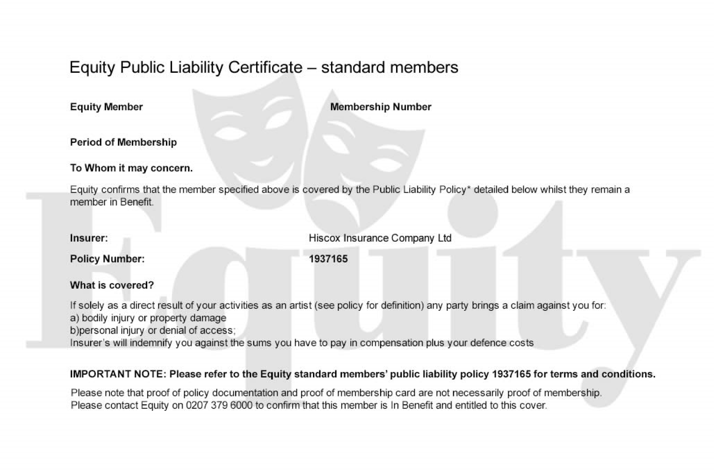

Nigel Dixon

00247610

Until 30 June 2016

Equity Member



